We will now switch tact and have a look at how all this works where we want to use a work area instead of a header line.

The fundamental difference is that when we are selecting records from the table, we are using the separate work area, instead of using the internal table's own header line.

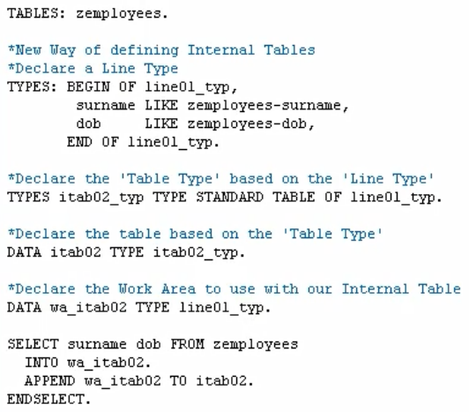

So, we have our normal SELECT statement. We specify it is going into our work area. Then, we have our APPEND statement and we're going to say append the record from the word carrier to our internal table. Then, this section of code is ended with the ENDSELECT to complete the loop.

